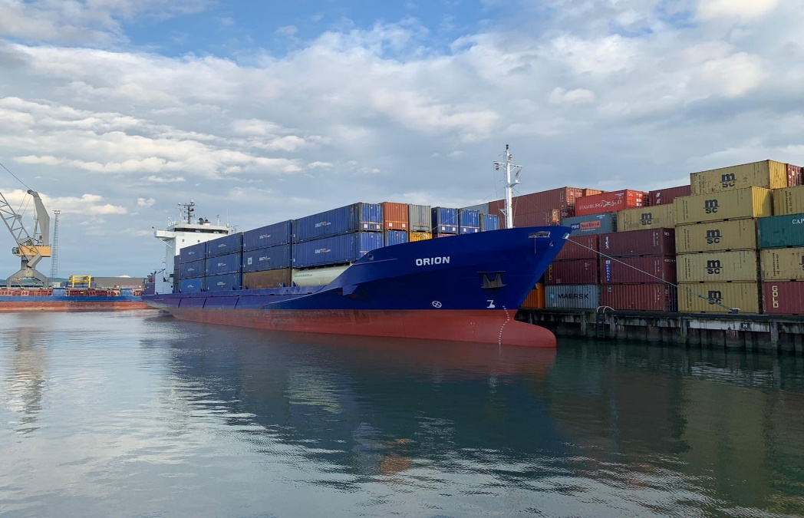



**BUILT 01 / 1998 AT KROEGER-SHIPYARD / GERMANY**

**GEARLESS/CELLULAR CONTAINER VESSEL**

**VOF Orion Zeilmakerstraat 3B 8601WT Sneek The Netherlands** [**info@vissershipping.nl**](mailto:info@vissershipping.nl) **+31515 431049**

**MV Spirit**

**MV Orion**

*All details ''about'' and given in good faith but without guarantee.*

|  |  |
| --- | --- |
| **Container capacity:** | 366 teu units 20’ x 8’ x 8'6''  Alternatively: 160 units 40’ x 8’ x 8'6'' plus 46 units 20’ x 8’ x 8'6''  220 teu of 14 mt homogeneously laden |
| **Main dimensions:** | Length overall 98,68 m  Length between perpendiculars 91,45 m  Breadth moulded 16,90 m  Gross tonnage 2.984  Net tonnage 1.311  Abt. 4.830 mtdwat sfb on abt. 5,91 mtrs |
| **Reefer plugs:** | 46 reefer points (female) of which 14 plugs located in hold and 32 plugs located on deck 440 volt/32 amp/60hz |
| **Class:** | G.l. + 100 a 5 e3, equipped for the carriage of containers, Solas ii-2, reg. 54 |
| **Vessel’s flag:** | Dutch flag |
| **Stowage hold:** | 40/40 1st/2nd tier  Alternativley: 34 units 40' plus 12 units 20' |
|  | Alternatively:16x 45 ft plus 14 x 30 ft 4x 40ft plus 8x 20 ft |
|  | Alternatively: 17/17 – 1st/2nd tier all 40; 6/6 – 1st/2nd tier all 20' |
| **Stowage deck:** | 286 units  Alternatively: 126 units of40' plus 34 units 20' |
|  | Alternatively: 113 x 45ft plus 7 x 40 ft |
|  | 66/68/68/64/20 1st/2nd/3rd/4th/5th tier including 20 units being stowed latitudinal  Alternatively:  30/30/30/30/6 – 1st/2nd/3rd/4th/5th tier all 40'  6/ 8/ 8/ 4/8 – 1st/2nd/3rd/4th/5th tier all 20'  Which are all being stowed latitudinal |
| **Fittings:** | No cells, but fully fitted with all necessary loose lashings/fittings to secure a full load of containers as described above  Vessel is also fitted for the carriage of 24,5'/30'/45'/49' containers (intakes and stowing examples will be given upon request) |
| **Stack weights:** | Strength of deck/hatches:  -tanktop-pointloadt: 50t/70t per 20'/40' stack on deck  -in front of bridge-pointload: 40t inner rows / 35t outer rows per 20' stack/50t inner rows – 60t outer rows per 40' stack  -on hatches-pointload: 40t inner rows / 34t outer rows per 20' stack/53t up to 55t inner rows; 60t outer rows per 40' stack  Always in conformity with vessels cargo securing manual. |
| **Holds / hatches:** | 1 hold/3 hatches  Hatch dimensions:  No.1 : 26.675 x 13.20/10.56 m  No.2 : 25.35 x 13.20 m  No.3 : 6.175 x 10.56 m  Transfolding type hatchcovers (kvaerner)  Abt. 4.450 cbm / 4.160 cbm g/b |

|  |  |
| --- | --- |
| **Main engine type:** | Man b&w 12 v 28/32a - fvo (2940 kw/775 rpm) |
| **Speed/**  **Consumption:** | Abt. 14,8 knots on abt. 13,6 mts ifo based on speed at 5,0 meters design draft at the condition of clean bottom and in calm and deep sea with main engine developing an ncr of 2.646 kw with fifteen percent (15 %) sea margin and even keel  Above consumption is given with shaft generator connected  Fuel consumption of the main engine applying i.s.o.  Reference conditions to the result of official shop test at an mcr of 2.940 kw using ifo.  Above figures based on good weather conditions of max 3 bft or douglas sea state 2 on clean and smooth bottom, currentless, calm and deep sea. |
| **Auxiliaries:** | 2 x 320 kva/1800 upm consuming mgo  Bowthruster of 350 kw |
| **Auxiliaries**  **Consumption**: | Port consumption basis no reefer connected: Abt 1 mt mgo |
| **Fuels:** | Charterers shall supply suitalble fuels to enable main  Propulsion and auxiliary machinery to operate efficiently  And without harmful affects. The fuel oil and mdo supplied  To be in accordance with iso 8217:2005 and rme 180; in addition. Density @ 15 degr not higher 990 kg/m3  maximum al/si content: 30mg/kg any fruther improvement any further of iso 8217will be included all fuels delivered to the vessel have to be a mineral oil based product and shall not contain taroil and/or inorganic acids/substances and/or used marine and/or other lubricants.  Removal of sludge always to be for charterers account |
| **Sampling:** | In order to make quite sure that a representativ sample is always available, drawn from the barge or when the fuel is passing the pipeline between suppliers barge and seagoing vessel samples have to be taken. Samples have to be sealed and labelled and shall be legally binding for all parties involved. The aforementioned samples will be used for analysis by messrs. Fobas. Costs for analysing will be shared equally. |
| **Tank capacities:** | Hfo abt 253 cbm  Mgo abt 47 cbm  Fw abt 48 cbm  Ballast abt 1.635 cbm |
| **Nautical aids /**  **Communication:** | Fitted with all modern nautical aids/satellite navigation; weatherchart-recorder/inmarsat system |
| **Ism-code:** | Vessel fullfills requirements of isps/ism-code |
| **Communication:** | Call sign: phia  Telephone: sat: 00870-764679441  Fax: sat : 00870-764679443  Mobile phone no. + 31-610970002  Telex sat c – no. 424604611@inmersat.com  Email: [orion@emailadvanced.com](mailto:orion@emailadvanced.com) / [phia.orion@vaart.net](mailto:phia.orion@vaart.net) |