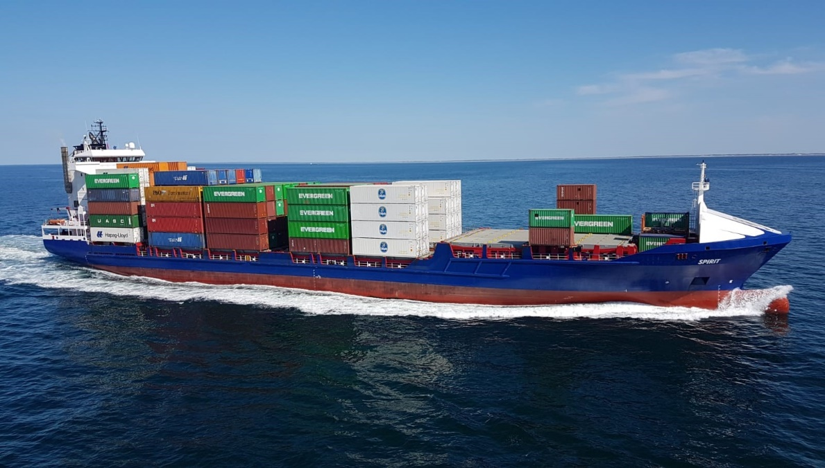
MV Spirit
GENERAL DIMENSIONS
- flag | : The Netherlands
- call sign | : PBQC
- built | : 11/2005
- imo nr. | : 9302255
- gl reg nr. | : 110955
- mmsi | : 212644000
- dwat | : abt. 9,600 mt, sfb- draft 7.30m
- ice class | : E-3 / 1-A
- loa | : 141.65 m
- lbp | : 132.42 m
- breadt moulded | : 20.60 m
- depth to maindeck | : 9.50 m
- draft | : 7.30 m
- airdraft from keel | : abt. 38 m
- class | : gl +100 a5 e3 ''containership'' ''solas ii/2 reg. 19'' + mc e3 aut
- GT/NT | : 7.713 gt / 3.785 nt
FULL SCANTLING GEARLESS CELLULAR CONTAINER FEEDER WITH ENGINE, BRIDGE AFT.
THE VESSEL IS FITTED WITH SWEDISH/FINNISH ICE CLASS 1-A

Spirit Shipping BV Zeilmakerstraat 3B 8601WT Sneek The Netherlands info@vissershipping.nl +31515 431049
CONTAINER INTAKE
- vessel able to load 20', 30', 40', 45', 48', 49'-units
(within ISO vissibility line of 2 times vessels length, and according to CSM)

TEU INTAKE:
in hold 1 76 teu (10/18/24/24)
in hold 2 84 teu (28/28/28)
in hold 3 78 teu (22/28/28)
-------------------------------------------
in hold ttl 238 teu (60/74/80/24)
on deck 571 teu (12/85/119/119/119/85/32) 1st/7th tier
incl 25x20' thwardships
-------------------------------------------
total 809 teu (units 20/8/8'6")

FEU INTAKE alternatively:
in hold 116 feu + 6 teu (28/36/40/12) (1st-4th tier)
on deck 264 feu + 43 teu (6/40/54/54/54/40/16) (1st-7th tier)
1st-7th tier incl 25x20' thwardships
------------------------------------------------------------------------------
total 380 feu (units 40/8/8'6") + 49 teu (units 20/8/8'6'')

HIGH CUBE-INTAKE:
- hold 1 : 1st-3rd tier 9'6''+ 4th tier 8'6''
- hold 2/3 : 3 tiers 9'6'' (all)
30' UNIT INTAKE (30'/8/8'6'')
- in hold 116 units + 0 feu + 6 teu
- on deck 198 units + 56 feu + 43 teu
------------------------------------------------------
total 314 units (30/8/8'6") + 56 feu + 49 teu (units 20/8/8'6'')

45' UNIT INTAKE (45'/8/9'6'')
- in hold 38 units + 82 feu + 6 teu (with cell guides removed hold no 1 : 47units +48 feu+6 teu)
- on deck 222 units + 0 feu + 18 teu
------------------------------------------------------
total 260 units (45/8/9'6") + 82 feu + 24 teu

- Cell guides in hold:
fully cellularized in holds 1 and 2 and 3 for 40' units,
alternatively 2x20' units can be stowed into each 40' compartment.
cell guides in holds are capable to accommodate 2.438mm/2.500mm wide boxes.
cellguide-system in hold 2/3 can be partly placed in 45' position.
- On deck all positions are capable to accommodate 2.438mm/2.500mm and even upto 2.595mm wide
boxes can be stowed.
- Vessel is fully fitted with loose lashing material/fittings.
- Containers on deck are lashed with stacking cones/twistlocks/ automatic twistlocks and lashing bars.
- Container intake always subject to vessel's stability, trim, strength, regulations of visibility, permissible
weights and at Master's discretion.

REEFERS:
200 reefer points female 3 o'clock 380 v/60 c.p.s./3 phases
whereof 122 on deck and 78 in holds
hold no.1 36 r/p
hold no.2 21 r/p
hold no.3 21 r/p

STACKWEIGHTS - POINTLOADS:
- in hold 1 90 ts per 20' stack
120 ts per 30'/40'/45' stack
- in hold 2/3 75 ts per 20' stack
105 ts per 30'/40'/45' stack
- on forecastle 60 ts per 20' stack
- on hatch 1 50 ts per 20' stack
80 ts per 30'/40'/45' stack
- on hatches 2/3 60 ts per 20' stack
100 ts per 30'/40'/45' stack
in front of bridge 60 ts per 20' stack
100 ts per 30' stack
100 ts per 40'/45' stack

distribution of container weights within a single 20'/30'/40'/45' stack on deck to comply with the board manual for stowage and lashing of containers by 'germanischer lloyd' (gl).

max. permissible distributed load:
tank top : 8 ts/m2
hatch covers : 1,75 ts/m2

MV Spirit
SPEED AND CONSUMPTION:
speed / consumption on design draught 7,30 m - loaded on even keel - based on good weather conditions max. bft.2 and max. sea temperature 20 degr.c., air temp.35 degr.c.

abt. 14,0 knots abt. 19,0 mt/day / if-380
abt. 15,0 knots abt. 22,5 mt/day / if-380
abt. 16,0 knots abt. 26 mt/day / if-380
abt. 17,0 knots abt. 29,5 mt/day / if-380

- no gasoil at sea except when shaftgenerator disconnected and auxs. in use like in cases of emergency
and/or navigation with reduced speed and/or in restricted areas like approaches, shallow waters, etc.

- port consumption of generators sets :
abt. 0.6 mtons mgo (dma) per 24 hours when idle per gen.-set
up to 3.7 mtons mgo (dma) when full load per gen.-set
- port consumption of oil fired boiler :
up to 2.4 mtons mgo (dma) when full load in winter
- Charterers to provide sufficient quantity of gasoil during sea passages for operating
auxiliaries/generators in case of an emergency.
- Charterers shall supply suitable fuels to enable main propulsion and auxiliary machinery to operate
efficiently and without harmful affetcs.

- Charterers to supply bunkers from 1a-bunker suppliers in accordance with:

ISO fuel Standard 8217 Dis 2005 RMG-380 for IF-380 and
ISO fuel Standard 8217 Dis 2005 DMA for gasoil

as well as MARPOL 73/78 Annex VI and subsequent revisions and European Union Directive
1999/32/EC and subsequent revisions

- sludge removal, if any, always to be for Charterers account/time.
- vessel participate in the DNV fuel quality testing programm.
Cost involved to be equally shared between Charterers and Owners.

TANKCAPACITIES:
- waterballast : abt. 3.800 mtons
- freshwater : abt. 111 mtons
- bunkers : abt. 950 mtons ifo
: abt. 300 mtons mgo (incl day & settling tanks)

ENGINE/AUXILIARIES/TECHNICAL EQUIPEMENT:
- Wartsila Type 8L46D, output 9.240KW at 500rpm (HFO)
- 2 diesel generators of 725 KW 906 KVA 60 Hz
- 1 emergency-/harbour generator set, 150KW, 60Hz
- 1 controllable pitchpropeller
- 1 shaft generator of 1500KW, 60 Hz
- 1 bowthruster 750KW
- 1 exhaust gasboiler (thermal oil)
- 1 oil fired boiler (thermal oil) (mdo dma)

STABILITY:
acc. to calculations/imo regulations vsl able to load:

abt. 573 teu each 12 to.
abt. 529 teu each 14 to.
abt. 474 teu each 16 to.
abt. 448 teu each 18 to.
abt. 406 teu each 20 to.

- vessel able to carry dangerous goods in holds and on deck in packed condition according to SOLAS
Regulations ii-2/19. on deck the stowage of all imo-classes of dangerous goods is permissible, except the
area between hatch 3 and deckhouse.

- in holds the stowage of imo-classes 1.4s, 2, 3, 4, 5.1, 6.1, 8 and 9 of dangerous goods is permissible. in
case of homogeneous container loading the stowage of all imo-classes of dangerous goods is
permissible also in front of the forward engine room bulkhead.

- dangerous goods of IMO-Classes 1, except class 1.4s, in containers must have a minimum horizontal
distance of 3.00m to engine room bulkhead.

HOLDS/HATCHES:
- 3 holds / 3 hatches
hatch 1 : abt. 25.44 m x 17.91/13.20 m
hatch 2: abt. 27.03 m x 17.91 m
hatch 3: abt. 27.03 m x 17.91 m
- mac gregor hydr. operated folding steel hatch-covers
- all 40'-sections can be handled separately / independently.
- CO2 fire fighting system in engine room and cargo holds
- Vessel's holds are electrically ventilated:
19-air changes/h basis empty holds.
- cargo capacity grain: abt. 440,000 cuft

Spirit Shipping BV Zeilmakerstraat 3B 8601WT Sneek The Netherlands info@vissershipping.nl +31515 431049
MV Spirit
MV Spirit
All details ''about'' and given in good faith but without guarantee.

