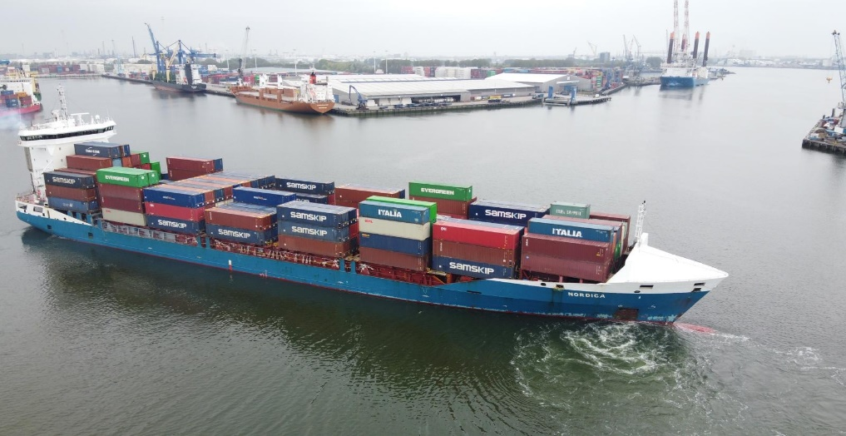

**MV Nordica**

t/c description: **m/v „nordica“ imo no. 9483695**

**yard -** sainty shipyard, china

**callsign -** p c s k

**flag -** the netherlands

**home port -** sneek

**built -** september 2011

**type -** containervessel – gearless engine/bridge aft

**class -** bv + 1 hull and mach inwater survey aut – ums ice 1a

containership – dangerous cargo – unrestricted navigation

(equal finish – swedish as per present regulations) **Main dimensions:**

**dwat -** abt. 13031 mt - with draft of abt. 8,00 m on draught summer

**gt / nt -** abt. 10318 / abt. 5391

**loa / lbp -** 151,72m / 142,42m

**breadth moulded -** 23,40m

**depth to maindeck moulded -** 11,75m

**holds/hatches -** 3 holds / 6 hydraulic operated flap covers which can be opened independently giving free access to each 40’/45’ bay underneath   
hold no. 1: divided by a crosswise beam in middle of hold; 1 access 12,48 m x 15,73 m; 1 access 12,48 m x 20,66 m

hold no. 2: no beam; 1 access 28,86 m x 20,66 m

hold no. 3: divided by a crosswise beam in middle of hold;

1 access 12,48 m x 20,66 m; 1 access 12,48 m x 20,66 m

**tank capacities -** hfo incl. settling tanks abt : 1042 cbm

mgo abt : 138,7 cbm

luboil storage abt : 61,8 cbm

ballastwater abt : 5500,6 cbm

freshwater abt : 150 cbm

**fitted with:**

**main engine -** man 8l 48/60 b; 9000 kw / 500 rpm

**auxiliary engines -** 3 x man -lindenberg d2842le 301; 620 kw / 1800 rpm

**generators -** 3 x leroy somer lsam 49.1 m6; 550 ekw

**emergency engine -** 1 x man-lindenberg d2876le 201; 405 kw / 1800 rpm

**generator -** 1 x leroy somer lsam 47.2 vs2; 315 ekw

**shaft generator -** 1700 ekw

**bow thruster -** 800 kw / 11 mto thrust

**propeller -** 1 alpha cpp vbs1460-odf 5,4 mtrs dia

**ballast system -** frank mohn as pump capacity 500m³ per hour

**reefer-points -** 255 reefer-points (female) whereof 116 in hold and 139 on deck (all 40’); 12,5 kw; 450 v; 60 cycle; earth pin position 3 hrs. vessel is equipped with an automatic reefer monitoring system (ptc). stowage of reefer containers in hold may effect stowage of dangerous goods in holds.

**others** co2 fitted, australian waters fitted, cargo computer fitted, holds 1 + 3 ventilated 15 x / hold 2 ventilated 24 x, suez and panama fitted

**navigation** fitted with all modern nautical aids, satellite navigation, weather chart recorder, inmarsat satcom, cruising range abt. 10000 nm.

**accomodation -** 16 + 2 persons

**cranes -** gearless

**Spirit Shipping BV Zeilmakerstraat 3B 8601WT Sneek The Netherlands** [**info@vissershipping.nl**](mailto:info@vissershipping.nl) **+31515 431049**

**MV Spirit**

**container intake according to imo regulations (8’/8’6’)**

|  |  |  |  |  |  |  |  |  |
| --- | --- | --- | --- | --- | --- | --- | --- | --- |
| Pos size | 20’ | 40’ | +20’ | 30’ | +20’ | 45’ | +20’ | +40’ |
| Hold | 322 | 156 | 10 | 188 | 8 | 62 | 10 | 94 |
| Hatchcovers | 514 | 257 | 0 | 257 | 0 | 257 | 0 | 0 |
| Deck fwd | 68 | 32 | 4 | 32 | 4 | 18 | 4 | 14 |
| Deck Aft | 132 | 66 | 0 | 66 | 0 | 66 | 0 | 0 |
| TOTAL | 1036 | 511 | 14 | 543 | 12 | 403 | 14 | 108 |

**9’6 high cube capability in holds -** full load of 4 tiers high cube containers 9’6 can be accomodated in all holds

**9’6” high cube capability on deck** -container at 40’:303 units on deck**;** container at 45’: 299 units on deck

**excessive breadth of containers** vessel is able to load container with an excessivebreadth of upto 2,50mtr on all positions in hold andon deck. vessel is able to load container with anexcessive breadth upto 2,60mtr on 5 inner rows on deck of hatch covers (40’ bays 10,14,18,22,26) and 4 inner rows bay 06.

**capacity of oversized containers** stowage of oversized containers with 30’and 45’unitsdoes not affect 20’/40’ blockstowage of containerson opposite bays and /or independent opening ofhatch covers. exact stowage detail for mixedstowage 20’/30’/40’/45’ to be taken from vesselsstowage plan and/or approved container securingmanual.

**cellguides in holds** fully cellularized in holds for 40’units. Alternatively 2x 20’units can be stowed into each 40’compartment. cellguides in hold no.1 and 3 are not removable and permanently fixed to vessel’s structure. middle cell guide in hold no. 2(“90”hold) to be removed on shore if 45’units or 3 bays at 30’units shall be stowed. maximum flexibility for mixed stowage of 4 bays at 2o’ and / or 3 bays at 30’ and / or 2 bays 40’and / or 2 bays at 45’containers is possible provided cellguide is removed. eventual removal and torage of removal cellguides on shore always to be at charterer’s risk and expenses

**stability example -** max.container intake basis imo when homogenous loaded

ts/teu: 740 teu

all above container intakes are maximum intakes always subject to vessel’s stability / trim / deadweight / permissible stress / permissible stackweights and visibility, bunkers on board and imo regulations of visibility. panama – and suez – canal or other local regulations may also require other visibility angle decreasing intakes.

**fittings -** vessel is fully fitted with loose lashing material and fittings according to osha rules. a mixture of both fully automatic and manual lashing material used on deck and stacking cones are used in holds to load the prescribed container cargo. If middle cellguide of hold no. 2 has been removed by charterers, containers in holds to be stowed with additional twistlocks instead of stacking cones. in this case charterers to deliver the amount of missing twistlocks, if necessary.

**strength of decks:**

tanktop - 12 mt/m2 - distributed load

weatherdeck - 1,75 mt/m2 - distributed load

**strength of decks:**

tanktop - 12 mt/m2 - distributed load

weatherdeck - 1,75 mt/m2 - distributed load

**container stackweights (metric tons)**

|  |  |  |  |  |
| --- | --- | --- | --- | --- |
| Pos size | 20’ | 40’ | 30’ | 45’ |
| Hold | 100 | 140 | 120 | 140 |
| Hatchcovers | 60 | 75 | 60 | 75 |
| Deck fwd | 60 | 90 | 75 | 90 |
| Deck Aft | 75 | 140 | 120 | 140 |

distribution of container- weights within a single 20’/30’/40’/45’stack on deck to

comply with the approved container securing manual.



**speed/consumption: -** abt. 18,5 kn at abt. 37,5 mt hfo without shaft generator connected. no mgo consumption at sea provided shaft generator connected except if hold ventilation is used, reefers connected and in case of emergency and/or navigation in shallow waters and/or reduced sped etc. charterers tp provide sufficient quantity of mgo during sea passages for operating auxiliaries/ generators and in case of emergency

**port consumption: -** vessel is consuming mgo in port for aux generators and pre-heating of hfo consumption abt. 1,75 mt mgo per day excl reefers, hold ventilation and tank heating. vessel could use upto abt. 9 mt mgo for preheating of hfo and full load of reefers/hold ventilation.

**fuel specification:**

the fuel oil suppilied to be in accordance with iso fuel standard 8217: 2010(e) rmg 380 or later amendments thereto calculated carbon aromatic index (ccai) not exceeding value of max. 860 the gasoil supplied to be in accordance with iso fuel standard 8217: 2010(e) dma or any later amendments thereto, except dencity max 0,86 at 15 degr. c.

charterers shall supply heavy fuel/gasoil/eca compliant fuel of such specification and grades to permit the vessel, at all times, to meet the requirements of any emission control zone as stipulated in marpol annex vi and/or zones regulated by regional and/or national authorities when the vessel is trading within that zone. charterers shall supply suitable fuel enable main propulsion and auxiliary machinery to operate efficiently and without harmful effects to contain no waste lubricants or chemicals. all fuel delivered to the vessel has to be a mineral oil product and shall not contain taroil and/or inorganic acid substances and to be of stable and homogen nature. vessel will participate in the fuel quality testing programme. samples will be taken during each bunkering, cost to be for charterers account and charterers will receive a copy of the fuel testing results. sludge removal, if any, to be for charterers account.

all above figures of speed and consumption are "about" whilst vessel is laying on even keel at design draught / having clean bottom / sea water temperature

max 28 degrees celsius and subject to good weather conditions i.e. wind force not exceeding beaufort 2, sea douglas state 2 and no negative influence by

currents and/or tidal streams.

*All details about and without guarantee and given in good faith but without guarantee*

**MV Nordica**

**Spirit Shipping BV Zeilmakerstraat 3B 8601WT Sneek The Netherlands** [**info@vissershipping.nl**](mailto:info@vissershipping.nl) **+31515 431049**

**MV Spirit**

*All details ''about'' and given in good faith but without guarantee.*